AETHERNOVA: CONSISTENCY & HABIT TRACKING SYSTEM
Project Documentation & Technical Summary Pre-Qualification Assignment: Full-Stack Developer Role Submitted by: Mukund Sharma
Date: 28/02/2026

1. Project Overview
- Project Name: AetherNova – High-Performance Consistency Tracker
- Objective: To build a clean, intuitive full-stack application that helps users track daily habits and stay consistent.
- Core Aesthetic: Cosmic Dark Mode / Glassmorphism (Premium SaaS feel).
- Architecture: Next.js 15 (App Router) + Express.js REST API + Prisma ORM + PostgreSQL.
- Deployment: Vercel (Frontend) + Render (Backend) + Supabase (Database).

2. Technology Stack
Category | Technology
Frontend | Next.js 15 (React 19), Tailwind CSS 3.4, Framer Motion
Data Viz | Recharts (Responsive Weekly Graphs), Heatmap Grids
Icons & UI | Lucide React, Radix UI (Headless), Sonner (Toasts)
State Management | SWR (Optimistic UI), React Context (Auth/Theme/UI)
Backend | Node.js, Express.js (TypeScript)
Persistence | Prisma ORM, PostgreSQL (Supabase), Cloud Pooling
Security | JWT (httpOnly Cookies), Helmet, Rate Limiting, Zod
Animations | Canvas Confetti, Framer Spring Physics, CSS Shimmers
DevOps | Vercel (CI/CD), Render (Server), Git + GitHub

3. Mandatory Requirements Compliance
Requirement | Implementation Detail
User Authentication | Secure registration/login with password hashing (bcryptjs), input validation (zod), and session management via httpOnly secure cookies.
Habit Management | Full CRUD lifecycle. Users can create, edit (title/desc/category), and delete habits. Habits are strictly scoped to the authenticated user.
Daily Tracking | Atomic completion markers. Database-level unique constraints  (habitId, date) prevent duplicate tracking. History is viewable via a 365-day heatmap.
Progress Dashboard | Dynamic calculation of current streaks, completion percentages, and weekly progress visualized via Recharts AreaChart.
Backend & DB | RESTful API structure with semantic status codes, clear data modeling, and strict error handling middleware.
Deployment | Publicly accessible at aethernova-consistency-tracker.vercel.app. Uses environment variables for secrets.

4. Bonus Features Implemented (Exceeding Requirements)
🎨 UX Improvements
- Ultra-Density UI: A custom precision polish pass ensuring the main dashboard fits within 100vh on laptops, eliminating unnecessary scrolling.
- Framer Motion Animations: Smooth layout transitions, spring physics on interactions, and staggered loading states.
- Dark Mode & Glassmorphism: High-end production aesthetic with blurred layers and vibrant glow accents.
- Smart Empty States: Custom designed illustrations and "Quick Action" buttons for new users.
🧩 Feature Enhancements
- Intensity Domains: 9 specialized habit categories with unique semantic styles.
- Reflection Notes: Ability to add/edit qualitative notes for every daily completion.
- Habit Freezing: "Snowflake" system to protect streaks during planned breaks.
- Daily Motivation: Deterministic motivational quotes that change every 24 hours.
🛠️ Technical Enhancements
- Docker Orchestration: Full
docker-compose.yml setup for 1-command local environment initialization.
- Rate Limiting: Tiered protection using express-rate-limit to prevent brute-force attacks.
- CI/CD Pipeline: Automated testing and deployment workflows via GitHub Actions.
- Vercel Rewrites: Secure proxying to treat the backend as first-party for cookie delivery.

5. Live Environment Links
- Live Dashboard: aethernova-consistency-tracker.vercel.app
- Backend API: aethernova-consistency-tracker.onrender.com
- GitHub Repository: github.com/mukund06s/aethernova-consistency-tracker

6. Engineering Decisions & Assumptions
- Decision (Secure Auth): Opted for httpOnly cookies over localStorage to eliminate XSS-based token theft, meeting high security standards.
- Decision (Normalized Dates): Used ISO YYYY-MM-DD strings for tracking to ensure consistency across user timezones, preventing "disappearing" completions.
- Assumption: User devices have JavaScript enabled (required for Next.js reactivity and Framer Motion).
- Assumption: A "day" is defined by the user's local system clock
7. Project Structure & Code Quality
The codebase follows a modular, type-safe architecture:
- Modular Components: Focused React components with clear prop interfaces.
- Custom Hooks: Business logic separated from UI (e.g., useChat,
useAuth).
- Singleton Prisma: Resilient database connection strategy to prevent leakages in high-concurrency environments.
8. ScreenShots
- Home Screen:
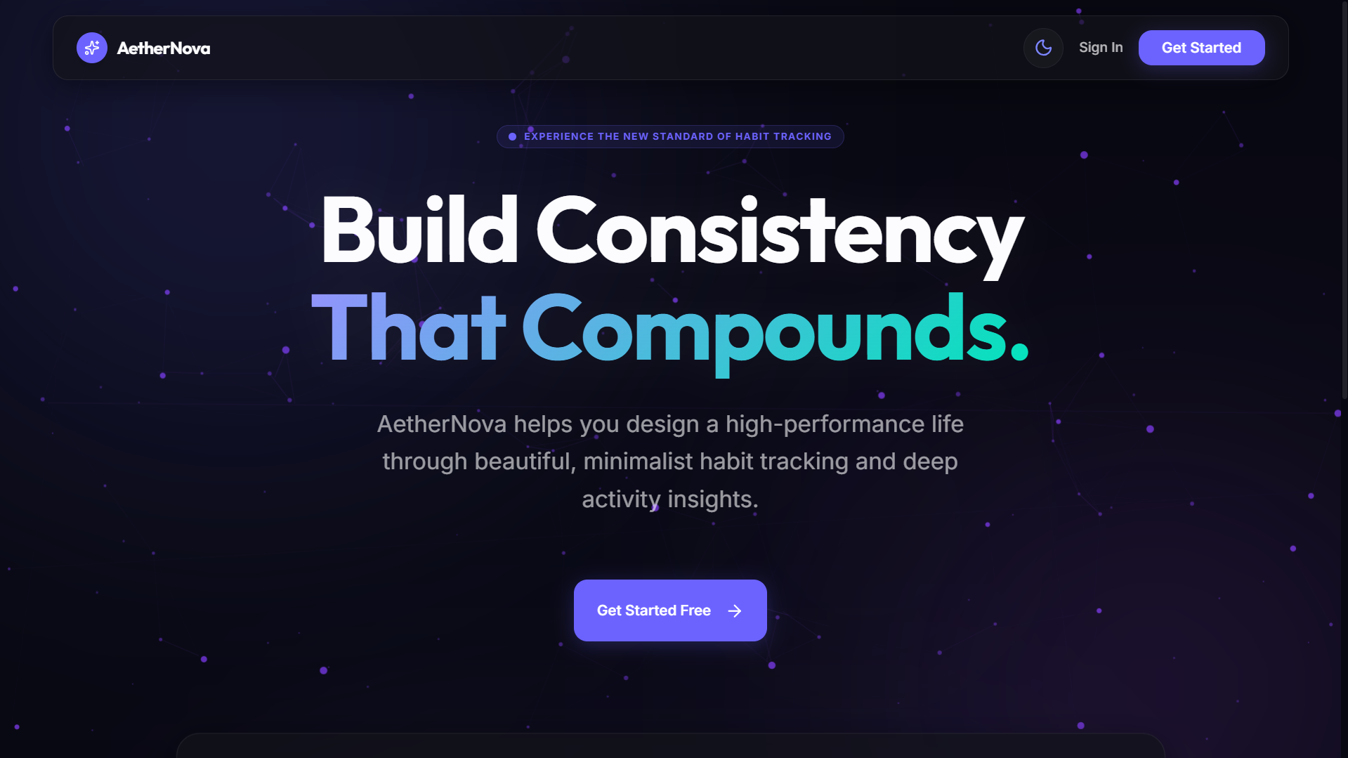

- Login Screen
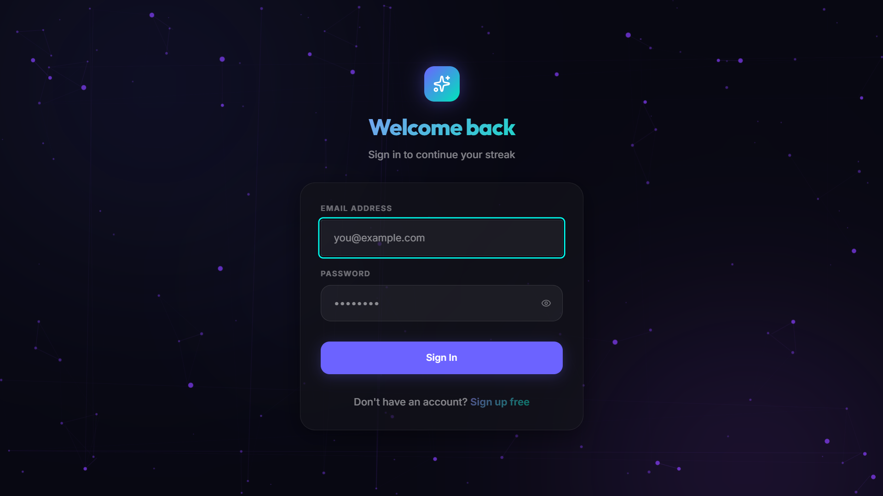
- Sign Up Screen
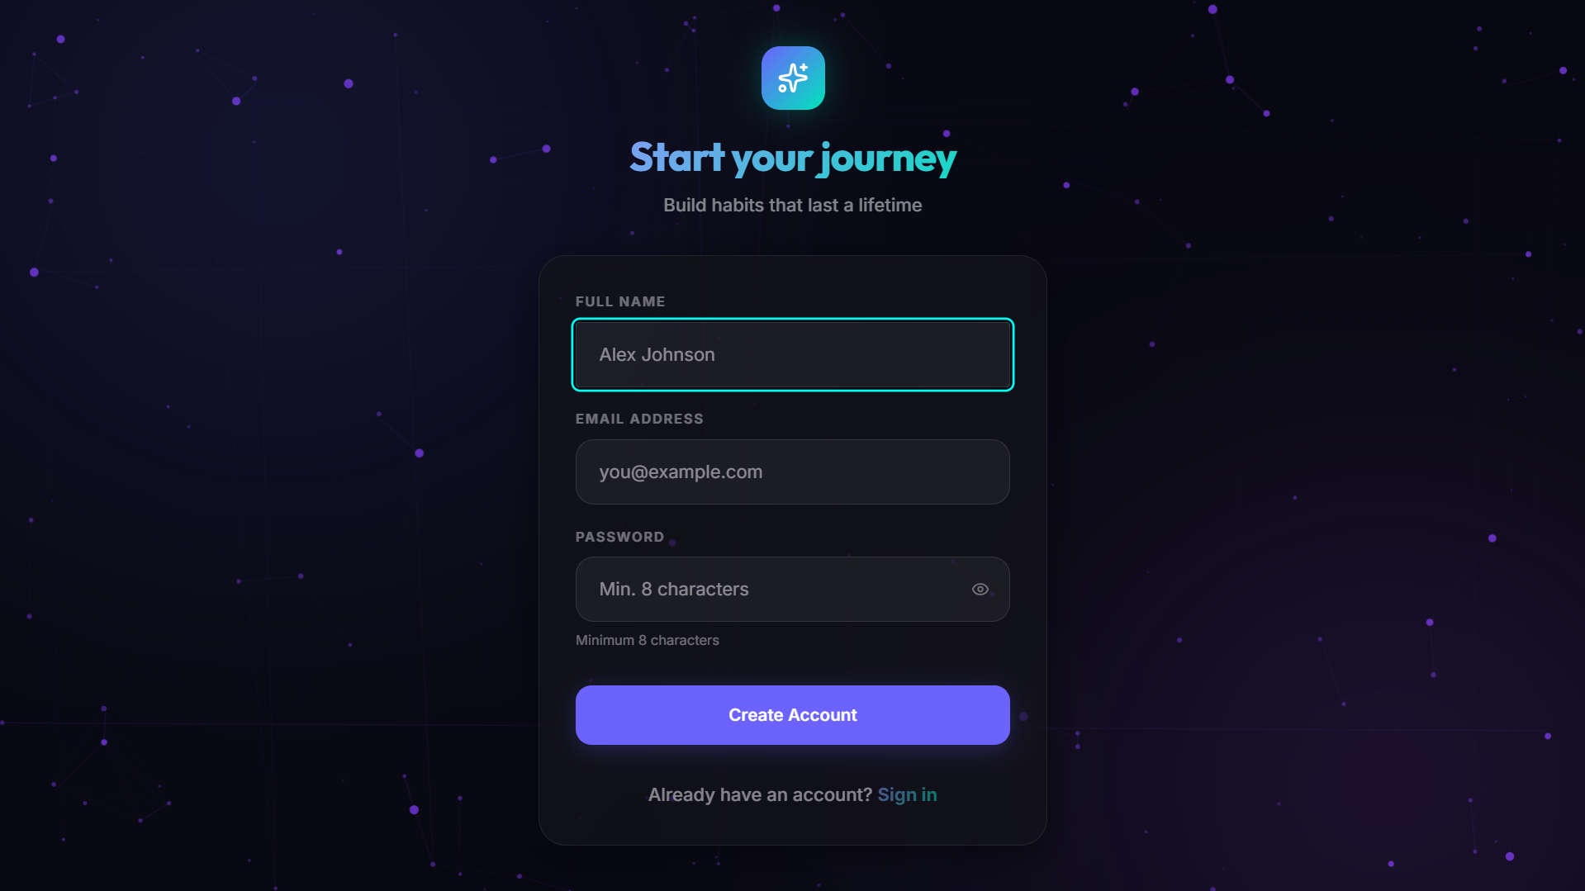

- Dashboard Screen
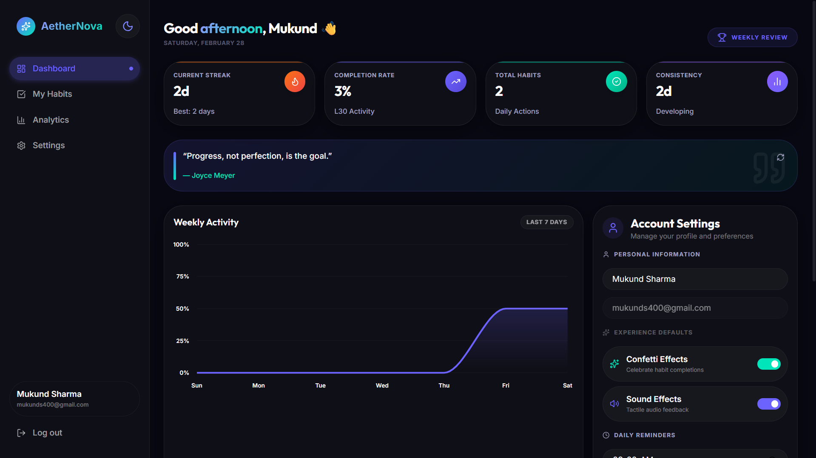
- Habit Screen
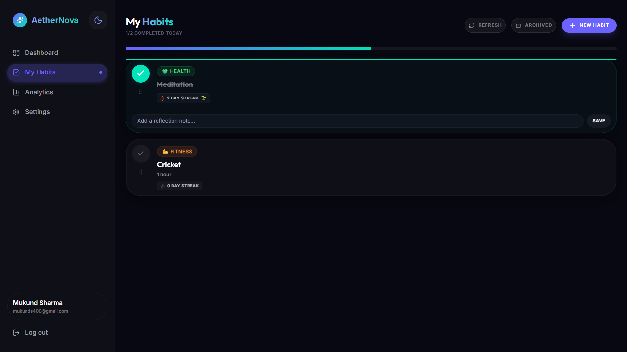

- Analytics Screen
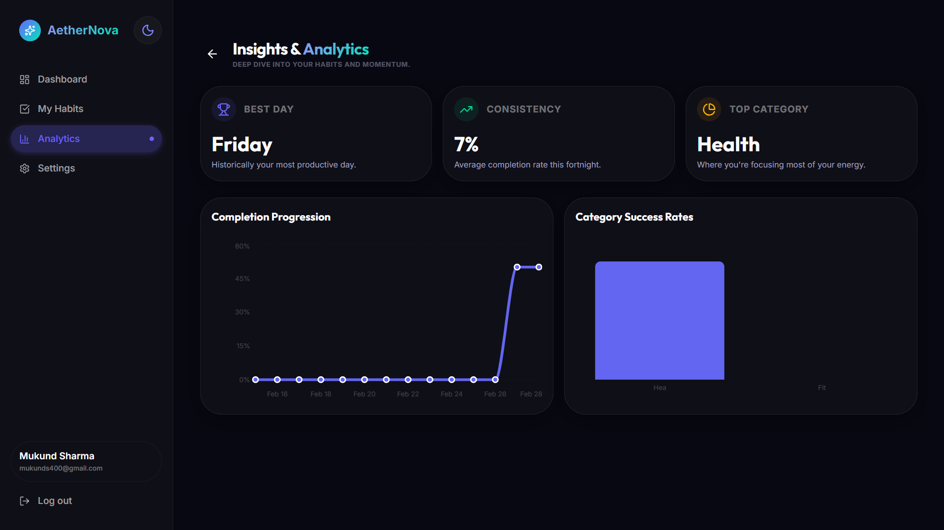
- Setting Screen
